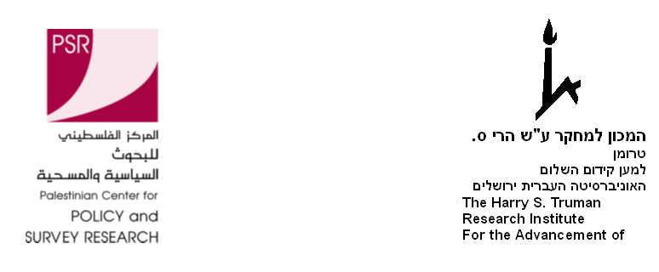
24 March 2008
PRESS RELEASE
Joint Israeli- Palestinian Public Opinion Poll*
THREATENED ISRAELIS AND PALESTINIANS DISENCHANTED WITH THE PEACE PROCESS AND SUPPORT FURTHER VIOLENCE
These are the results of the most recent poll conducted jointly by the Harry S. Truman Research Institute for the Advancement of Peace at the Hebrew University of Jerusalem and the Palestinian Center for Policy and Survey Research in Ramallah, between March 12 and 17, 2008.

The weeks preceding the poll were characterized by increased violence between Israel and Hamas in the Gaza Strip, with Hamas intensifying its rocket shelling on Israeli civilian communities; an
Israeli incursion into Gaza that left more than 130 Palestinians dead; and a shooting attack in West Jerusalem that led to the death of 8 Israeli religious students.

The joint poll examined Israelis and Palestinians’ assessments of the negotiations launched by the Annapolis conference and are currently going on between Olmert and Abu Mazin. It further examined Israeli and Palestinian attitudes regarding a permanent settlement along the lines of the Saudi (Arab league) plan and Israelis’ attitudes towards a full evacuation of the Golan Heights in return for a complete peace agreement with Syria.

The findings indicate that both Israelis and Palestinians do not hold high hopes for the Abu Mazin–Olmert talks, don’t see them as beneficial and believe they should be stopped. With regard to the Saudi plan, Israelis oppose it while Palestinians support it. A majority of Israelis also oppose the evacuation of the Golan for peace with Syria. At the same time there is considerable support for launching rockets and suicide attacks among Palestinians, and support for retaliatory operations in Gaza among Israelis. This combination looks explosive and may perpetuate further escalation in violence between the two sides.

The Palestinian sample size is 1270 adults interviewed face-to-face in the West Bank and Gaza Strip in 127 randomly selected locations between March 13 and 15, 2008. The margin of error is 3%. The Israeli sample includes 597 adult Israelis interviewed by phone in Hebrew Arabic or Russian between March 12 and 17, 2008. The margin of error is 4%. The poll was planned and supervised by Dr. Yaacov Shamir, the Harry S. Truman Research Institute for the Advancement of Peace and the Department of Communication and Journalism at the Hebrew University and Dr. Khalil Shikaki, director of the Palestinian Center for Policy and Survey Research (PSR).

For further details on the Palestinian survey contact PSR director, Dr. Khalil Shikaki or Walid Ladadweh, at tel. 02-296 4933 or email pcpsr@pcpsr.org. On the Israeli survey, contact Dr. Yaacov Shamir at tel. 03-6419429 or email jshamir@mscc.huji.ac.il.

*This joint survey was conducted with the support of the Ford Foundation Cairo office and the Konrad Adenauer Foundation in Ramallah.

MAIN FINDINGS

(A) Peace Process:
- 57% of the Israelis oppose and 40% support the Saudi initiative which calls for Arab recognition of and normalization of relations with Israel after it ends its occupation of Arab territories occupied in 1967 and after the establishment of a Palestinian state. Among Palestinians, 66% support the plan and 32% oppose it
- 44% of the Israelis support and 54% oppose talks with Hamas if needed to reach a compromise agreement with the Palestinians. However a sizeable Israeli majority (62%) support and only 34% oppose talks with a national unity government composed jointly of Hamas and Fatah if such a government is reestablished.
- Similarly, 45% of the Israelis support and 51% oppose the release of Marwan Barghouti from prison and negotiation with him, if needed to reach such an agreement.
- 67% of the Israelis support and 29% oppose mutual recognition of Israel as the state for the Jewish people and Palestine as the state for the Palestinian people as part of a permanent status agreement. Among Palestinians, 55% support and 44% oppose this step.
- 53% of the Israelis believe that the meetings between Mahmud Abbas and Ehud Olmert are not beneficial and should be stopped while 39% believe they should continue. Palestinians show greater disappointment with these talks. Among Palestinians a sizeable majority of 75% believe the talks should come to a halt while only 21% believe they are beneficial and should be continued.
- 66% among Israelis and 68% of the Palestinians believe that the chances for the establishment of a Palestinian state during the next five years are non-existent or weak. Only 31% of Israelis and 30% of Palestinians believe chances are fair or high.
- 59% of Israelis oppose full evacuation of the Golan Heights in return for a complete peace agreement with Syria, and 25% support it.

(B) Threat perceptions and support of violence

Following the renewed wave of violence, both Israelis and Palestinians’ threat levels increased significantly compared to our December 2007 poll.
- Among Israelis, 74% are worried that they or their family may be harmed by Arabs in their daily life, compared to 64% in our December 2007 poll -- an increase of 10 percentage points. Among Palestinians 63% fear that their security and safety and that of their family is not assured compared to 53% three months ago, a similar 10 percentage points increase.
- 13% of the Israelis also fear that Hezbollah will react to the assassination of Imad Mughniyeh by resuming the bombing and shooting of IDF forces along the border, 21% fear that it will retaliate by resuming the rocket launches on Israeli towns, 42% believe it will perform terrorists attacks against Jews and Israelis around the world and only 13% believe it will restrain itself and will not respond.

Consistent with the gloomy expectations from the peace process and the heightened threat feelings, Palestinians support of violent acts against Israel is staggering while Israeli support for military action in Gaza remains stable.
- An overwhelming majority of 84% support and 13% oppose the shooting attack that took place in a religious school in West Jerusalem. Support for this attack is greater in the Gaza Strip (91%) compared to the West Bank (79%).
- 64% support and 33% oppose launching rockets from the Gaza Strip against Israeli towns and cities such as Sderot and Ashkelon.
- Among Israelis only 27% believe that if the shelling of Israeli communities from the Gaza Strip continues, Israel should use primarily diplomatic rather than military steps, 29% of the Israelis suggest that Israel should reoccupy the Gaza Strip and stay there and 41% think that Israel should carry out ad-hoc operations against the shelling and get out. Surprisingly these figures did not change from three months ago.

